Setup and configuring MongoDB

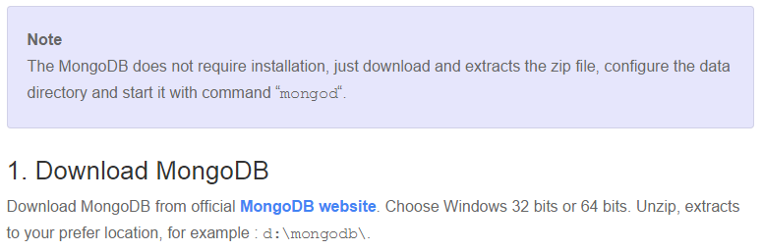
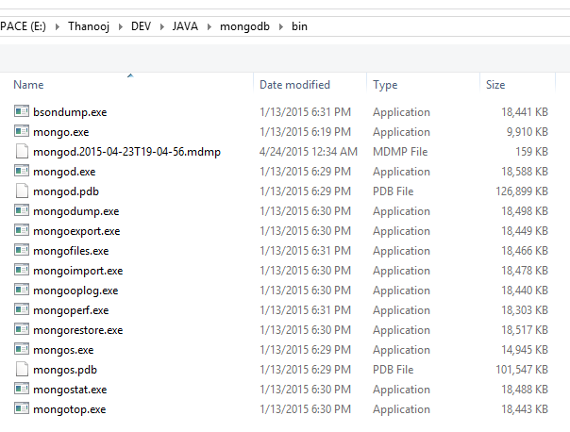

- Running MongoDB as a standalone server
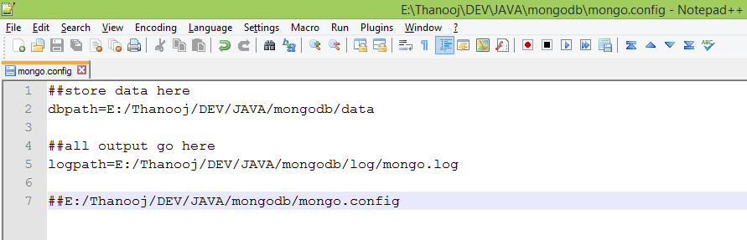

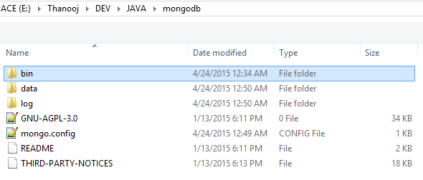
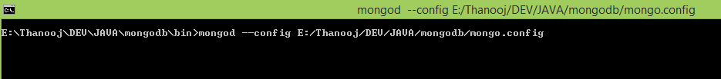
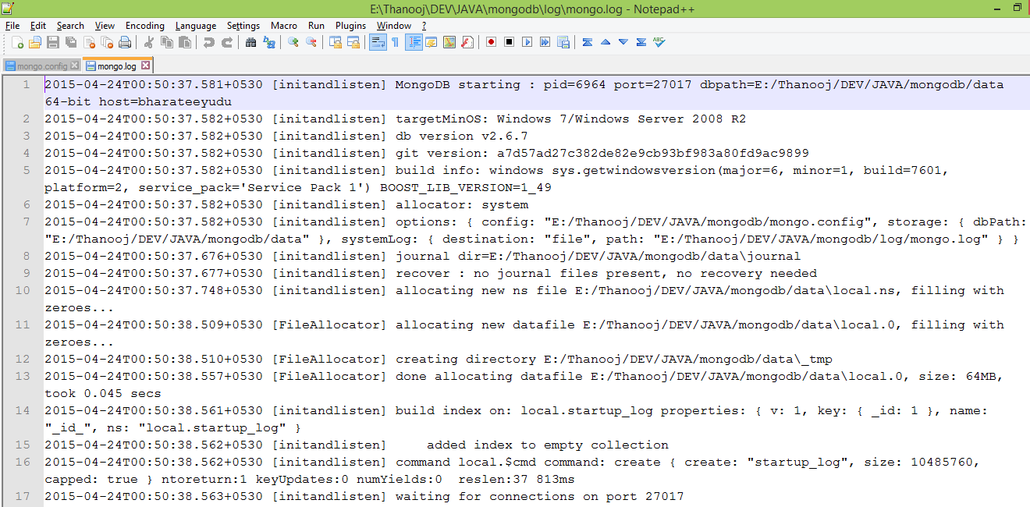
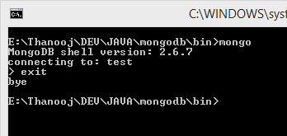

2. MongoDB as a Service on windows :
install – start – stop – remove service
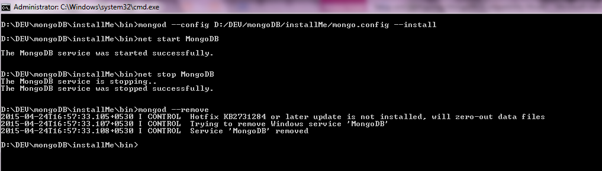
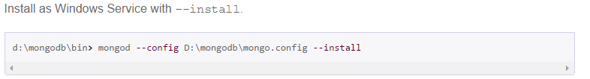
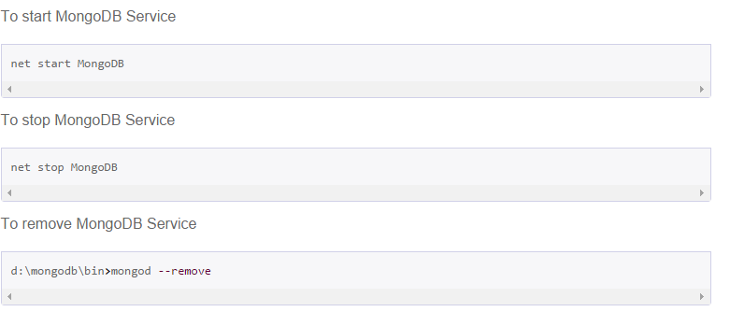

Log file : install – start – stop – remove service
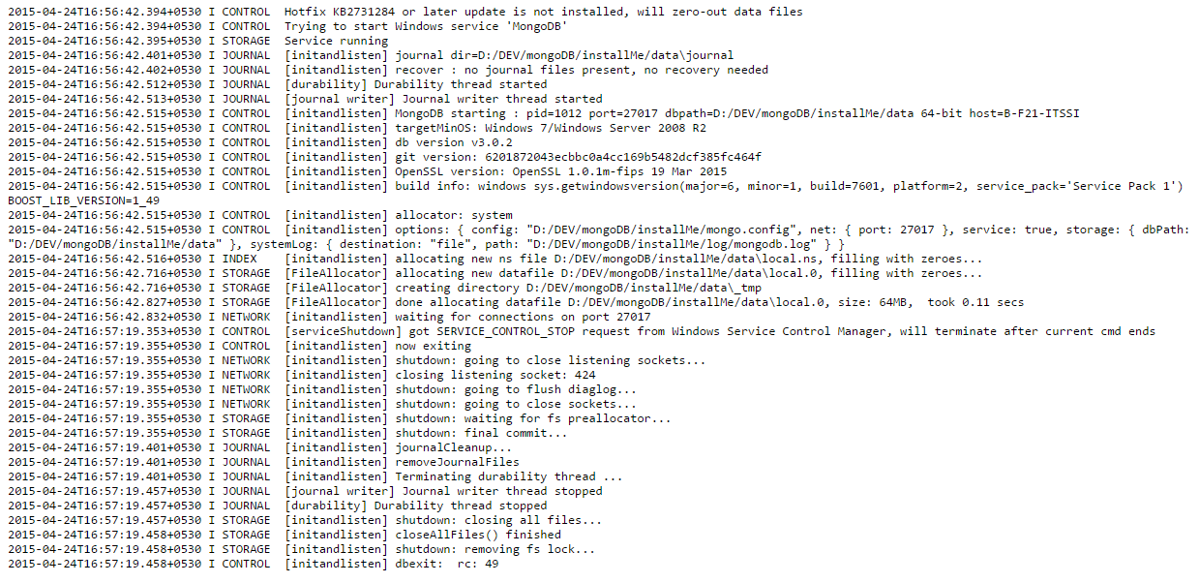

OR
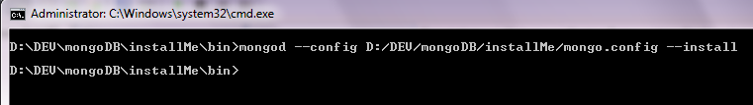
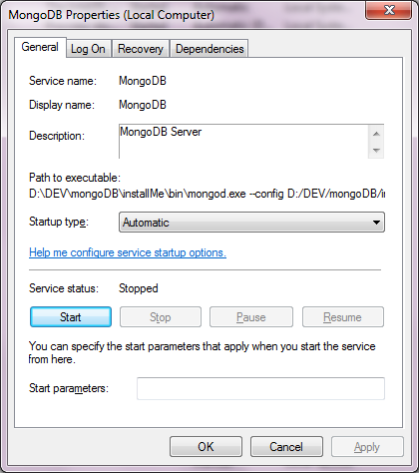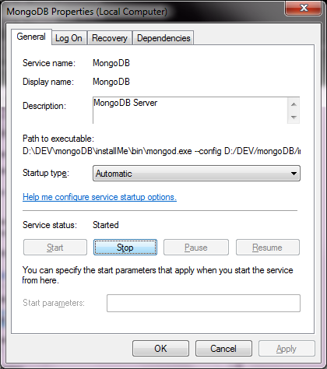

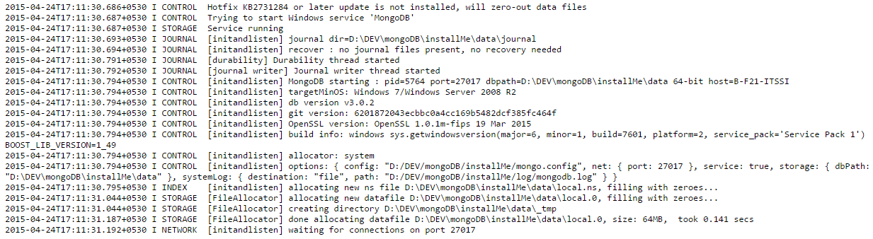
Client connecting to “test”

For more info:
http://docs.mongodb.org/manual/tutorial/install-mongodb-on-windows/
http://www.mkyong.com/mongodb/how-to-install-mongodb-on-windows/
http://blog.ajduke.in/2013/04/10/install-setup-and-start-mongodb-on-windows/

